1. To join the game: User send the userId. If this userId is new, it is added and true is returned. If this userId is used by someone elase, then false is returned and player need to use new userid.

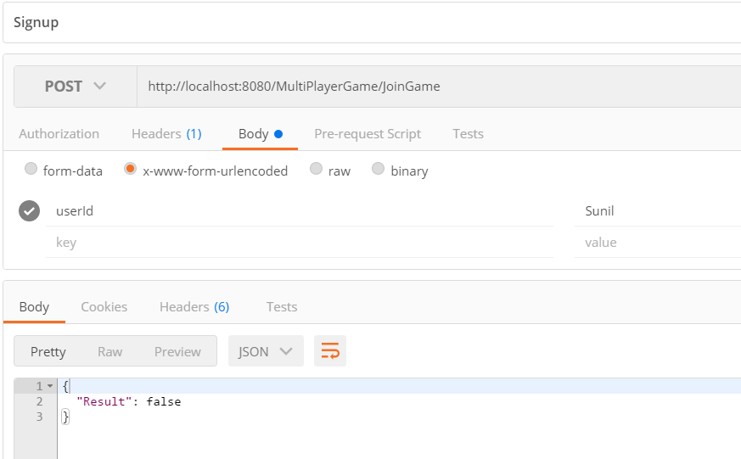

1. To leave the game: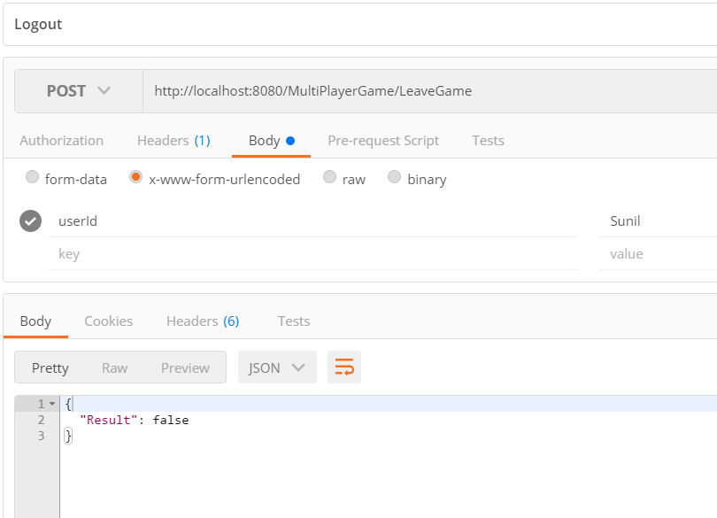
2. Update your status and get all players data

